**Welcome to Changemaker Chronicles!**

This is not your standard ‘newsletter’ because our mission is anything but standard! We dream for BIG impact and make that dream a reality with the villagers of Roche, Burere and Nyambogo in Tanzania, Africa!

Each month we will share stories of the people we work with and how they connect **to lifelines of resources**…thanks to people like you. And of course, there will be pic’s!

To launch our 1st issue, meet Timoth, a Village Life ‘Changemaker in Action’!

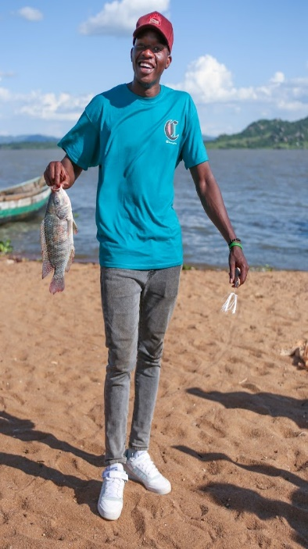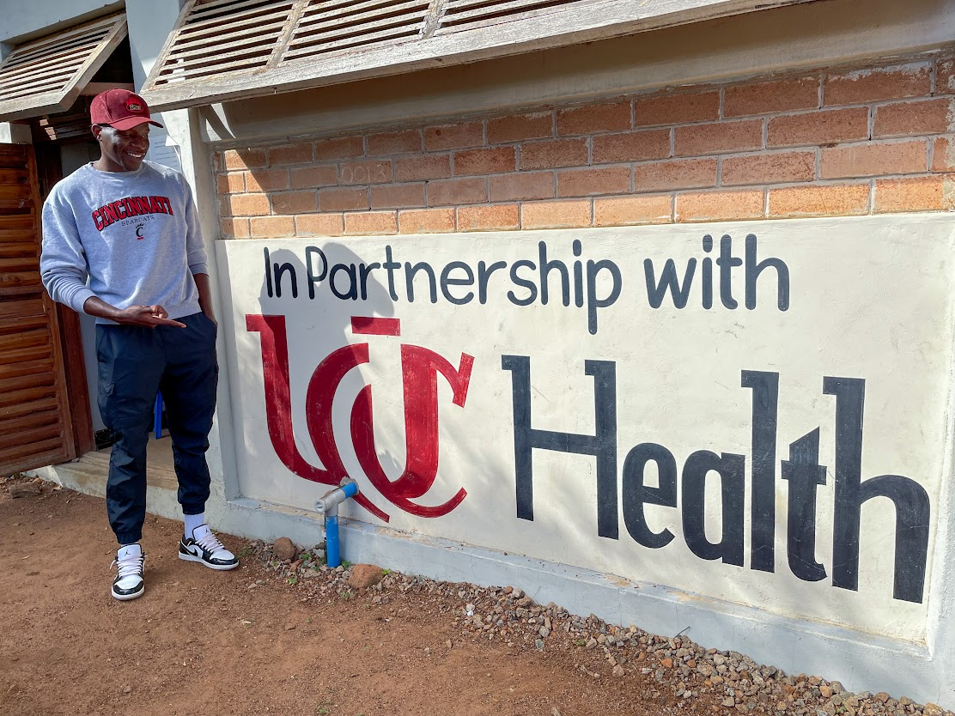

Timoth (Timo) Akama is a Tanzanian native who worked as a nurse/midwife in a remote village in Tanzania for two years before pursuing a bachelor’s degree in public health at the University of Cincinnati. His decision to enter the field of public health was motivated by the observation that many patients in the village struggled with social determinants of health. He values close community engagement as an essential aspect of solving social issues.

To Timo, being a 'changemaker in action' means taking proactive and creative steps to address social problems in the community. It involves actively working towards positive change by understanding the root causes of issues, empathizing with the affected population, and implementing innovative solutions to improve the well-being and health of the community.

Timo continues to be a changemaker today by pursuing his education in Public Health at the University of Cincinnati. He is equipping himself with the knowledge and skills needed to address the social determinants of health and other public health challenges. He also maintains a strong connection with the community, which allows him to stay informed about their needs and collaborate on effective solutions. His commitment to education and community engagement makes him an ongoing changemaker.

In his free time, Timo enjoys spending quality moments with his loved ones, fostering strong relationships and connections. Additionally, he finds relaxation and enjoyment in playing volleyball, which not only provides physical activity but also reinforces the importance of teamwork and cooperation, qualities that are valuable in his work as a changemaker in public health.

**Thank you, Timo, for making the decision to bring change to our world!**

We are always on the lookout for Changemakers – please nominate someone (or yourself, it’s encouraged!) and share how you’ve given back and made a difference!

Life, Health, and Education are the 3 pillars of Village Life that drive our efforts as a catalyst for change. We will be sharing specifically how that looks in future issues, but for now…check out our WIG’s (Wildly Important Goals!).

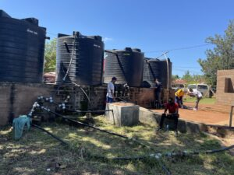**Life Aspirational Goal: *Develop a system to provide self-sustaining access to and utilization of safe drinking water, sanitation, and hygiene*** for residents of Roche, Nyambogo, & Burere. The final plan must incorporate economic development opportunities in each village that sustain the cost of the programming and increase income for community members.

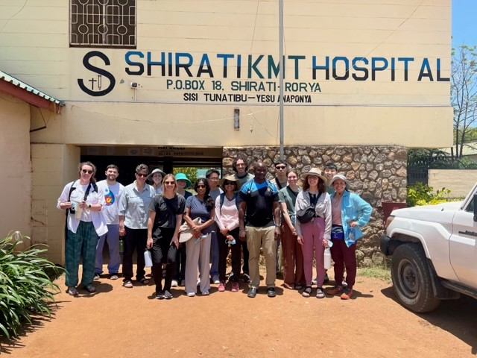

**Health Aspirational Goal: *Create a model Academic Health Center of excellence for rural East Africa*** that provides access to sustainable health care to residents of Roche, Nyambogo, & Burere. In this, the training of residents, outreach to neighboring villages, research, and preventive care need to be included.

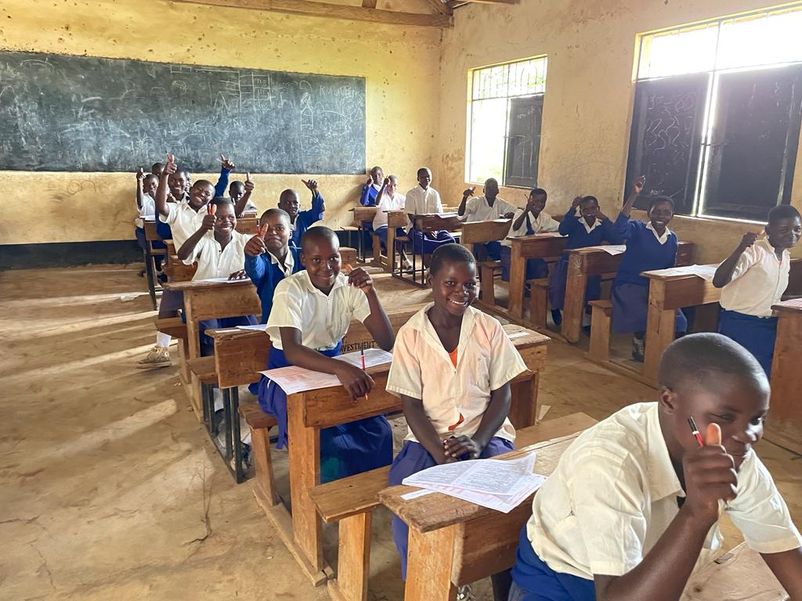

**Education Aspirational Goal**: Within the current education system, ***create learning opportunities for all ages in primary and secondary schools, as well as Adult Education Programs***. Developing partnerships with other educational institutions will be crucial to encourage academic growth in village residents.

**Just for Giggles because we all need a laugh a day!**

